# 

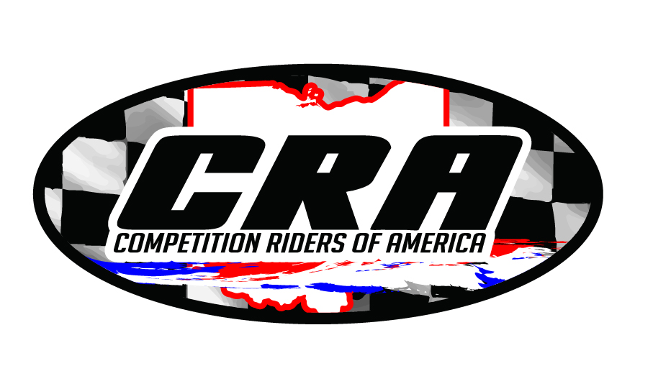 Competition Riders of America

Proudly Announces

Our 41st Annual Awards Banquet

SAVE When…………. Saturday, January 20, 2024

THE Time………….. 6:00 p.m.

DATE Where………… Yankee Lake Ballroom

1800 State Rt. 7 North, Brookfield, OH 44403

You do not need to be an award winner to join the fun.

Year-end & Series award winners will be listed on the CRA website

We do ask that you purchase your tickets by January 6th so the caterer can prepare accordingly.

Please use the form below to order your $35.00 tickets.

A limited number of Tickets will be available at the door for $40.00 each

Prize drawings and giveaway’s all night long

Surprise Raffles 50/50 $$ Raffle

Series Awards Track Awards

Join us for all of the fun and excitement!!

------------------ Cut here and mail for your tickets by January 6, 2024 -----------------

# 2023 C.R.A. AWARDS BANQUET TICKET ORDER FORM

Office Use: Ticket #_______________________

Name:_________________________________ Ticket Prices:

$35.00 each

Address:_______________________________ Any tickets purchased at the door will be $40.00

City:__________________, State:_______ # of Tickets ______x $35.00 =________

Zip:____________ Your phone # (____) _______________ (children under 4 are FREE)

Checks / Money orders are payable to C.R.A. and mailed to: C.R.A.

10230 Duck Creek Rd.

Salem, Oh 44460